**Dam Breaking on a column**

**Shallow Water Equations**

**1)Important Info’s: -**

**🡺***Wave impact problems are important in engineering of structures, for example in locations where tsunamis are probable.*

**🡺***This transient model solves the shallow water equations to model the impact of a water wave on a column.*

**🡺** *A body of water with a height of 0.3 m is initially contained behind a gate. At the start of the simulation, the gate is suddenly released and the body of water forms a wave moving toward the structure.*

**🡺***After impacting, the water continues its forward movement until it is reflected from the wall of the tank and impinges the second time on the other side of the column.*

**🡺***The pressure force on the column is computed and can be compared with the experimental results.*

***2)*Physics and Equations: -**

**🡺***A* ***1.60 m long, 0.61 m wide, and 0.60 m high*** *tank was used.*

*🡺* ***A 0.40 m long, 0.61 m wide, and 0.30 m high volume of water*** *is initially contained behind a gate which is instantly released at the start of the simulation.*

*🡺A tall solid column with* ***0.12 m wide square base*** *is placed inside the tank* ***0.50 m downstream*** *of the wall and* ***0.25 m*** *from one of the sidewalls.*

*🡺In the shallow water equations, the pressure is assumed to be hydrostatic.*

***P= ρg (h+ hb-z);***

***🡺****The pressure force per unit length on a boundary can be obtained integrating along h:*

*🡺* *After the release of the gate, the body of water collapses due to gravity and forms a wave moving toward the column.*

*🡺After impacting on the structure, the wave front is torn so that its central part rides up the column’s upstream face. The sides of the wave rejoin in the wake downstream the structure and are reflected by the downstream wall of the tank.*

*🡺The wave is weakened after the reflection and impinges again on the column from the downstream side. The wave continues toward the upstream wall where it is reflected once more, but it is gradually decaying.*

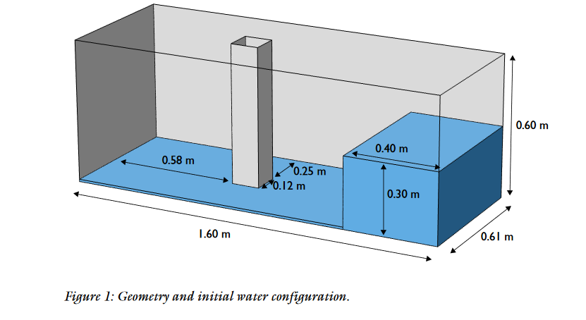

**2)Results: -**

**🡺***Total Height(3D) and Bottom Height(3D) plot: -*

|  |  |  |
| --- | --- | --- |
| *T=0 sec* | *T=0.3 sec* | *T=0.6 sec* |
|  |  |  |
| *T=1 sec* | *T=1.3 sec* | *T=1.6 sec* |
|  |  |  |
| *T=2 sec* | *T=2.3sec* | *T=2.6 sec* |
|  |  |  |
| *T=2.7 sec* | *T=2.9 sec* | *T=3 sec* |
|  |  |  |

**🡺***Velocity Magnitude Plot(2D): -*

|  |  |  |  |
| --- | --- | --- | --- |
| *T=0 sec* | *T=0.3 sec* | *T=0.6 sec* | **Color Legend** |
|  |  |  |  |
| *T=1 sec* | *T=1.3 sec* | *T=1.6 sec* |  |
|  |  |  |  |
| *T=2 sec* | *T=2.3sec* | *T=2.6 sec* |  |
|  |  |  |  |
| *T=2.7 sec* | *T=2.9 sec* | *T=3 sec* |  |
|  |  |  |  |

**🡺Streamlines Plot: -**

|  |  |  |
| --- | --- | --- |
| *T=0 sec* | *T=0.3 sec* | *T=0.6 sec* |
|  |  |  |
| *T=1 sec* | *T=1.3 sec* | *T=1.6 sec* |
|  |  |  |
| *T=2 sec* | *T=2.3sec* | *T=2.6 sec* |
|  |  |  |
| *T=2.7 sec* | *T=2.9 sec* | *T=3 sec* |
|  |  |  |

**🡺*Pressure force on the column vs Time plot: -***

